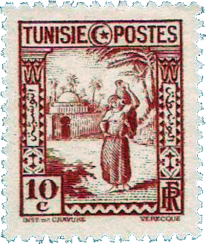
ADVANCED PLACEMENTENGLISH

Peter Viereck:

Vale from Carthage (Spring, 1944)
 | I, now at Carthage. He, shot dead at Rome.
 | Shipmates last May. “And what if one of us,”
 | I asked last May, in fun, in gentleness,
 | “Wears doom, like dungarees, and doesn’t know?”
5 | He laughed, “Not see Times Square again?” The foam,
 | Feathering across that deck a year ago,
 | Swept those five words—like seeds—beyond the seas
 | Into his future. There they grew like trees;
 | And as he passed them there next spring, they laid
10 | Upon his road of fire their sudden shade.
 | Though he had always scraped his mess-kit pure
 | And scrubbed redeemingly his barracks floor,
 | Though all his buttons glowed their ritual-hymn
 | Like cloudless moons to intercede for him,
15 | No furlough fluttered from the sky. He will
 | Not see Times Square—he will not see—he will
 | Not see Times
 | change; at Carthage (while my friend,
 | Living those words at Rome, screamed in the end)
20 | I saw an ancient Roman’s tomb and read
 | “Vale” in stone. Here two wars mix their dead:
 | Roman, my shipmate’s dream walks hand in hand
 | With yours tonight (“New York again” and “Rome”),
 | Like widowed sisters bearing water home
25 | On tired heads through hot Tunisian sand
 | In good cool urns, and says, “I understand.”
 | Roman, you’ll see your Forum Square no more;
 | What’s left but this to say of any war?

Directions: Read the poem carefully. Then answer fully and explicitly the following questions:
- Does the structure of the three opening sentences fit this particular poem? Give reasons for your answer.
- Why do the three place names — Carthage, Rome, and Times Square — create the particular emotional effects present in this poem?
- Interpret each of the following portions of the poem so as to show how it contributes to the effectiveness of the poem as a whole:
- Wears doom, like dungarees (line 4);
- …. they laid
Upon his road of fire their sudden shade (lines 9-10);
- No furlough fluttered from the sky (line 15);
- Living these words (line 19);
- Like widowed sisters (line 24).
- To whom does I refer in line 26? What is it that is understood?
- To how much may this refer in the final line of the poem?

Vale is the Latin word for farewell.
Carthage is the site of the famous ancient city in Tunisia, North Africa. In ancient times the rivalry between Rome and Carthage culminated in the Punic Wars. In World War II, Tunisia again figured prominently.
Times Square is the bustling center of New York City—the theater district.

